**2025 WILDFLOWER TRAILS**

**CASS COUNTY HISTORIC STAMP ART SHOW REGISTRATION FORM**

**April 25 & 26, 2025**

**Stamp Art Delivery: 5 -7 P.M. Tuesday, April 22, 2025; Stamp Art Pickup: 5 P.M. Saturday April 26, 2025**

**The Linden Wildflower Art Show is holding a contest for artists’ work of any 1852 until 2024 historic events and/or people in Cass County to be featured on a stamp. Each stamp will feature a painting/drawing/photograph of the historical event/person along with a message detailing the historical significance of the entry on the stamp. Entries are to be placed on a 3 X 5 card (index card).**

**Adult: Entry fee for each piece: $5 with a limit of 3 entries**

**Teens: Entry fee for each piece: $3; limit of 3 entries**

**Children: Entry fee for each piece: $1.00; limit of 3 entries**

**Historic Stamp Prize**

Best of Show: $100

**Children Teens Adult**

1st place - $15 1st place - $30 1st place - $75

2nd place - $10 2nd place - $20 2nd place - $50

3rd place - $5 3rd place - $10 3rd place - $30

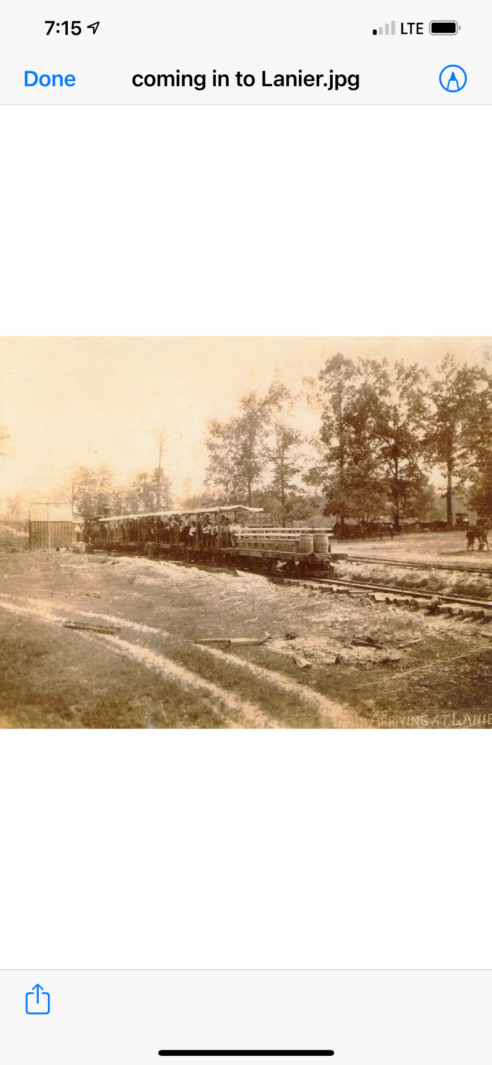

**The Jefferson and Northwestern ( J & NW RR) Railroad entered Lanier in 1912.  It bypassed Lanier by three miles.  Lanier residents responded by relocating the community to its present location to be near the railway.  The J & NW RR served Linden and the surrounding communities from 1899 until 1941.**



**Sample Entry of a Cass County Historic Stamp**



**Cass County Historic Stamp Registration Form**

Artist’s name _______________________________________________________________________

Adult: ________ Amateur: ______ Professional: ____________

Student: ________ Grade: ___________

Cell Phone: ___________________ Email: _________________________

City: ________________

Stamp Entry 1: Title_________________________________________

Historic Significance ________________________________________________________________________

Stamp Entry 2: Title_________________________________________

Historic Significance ________________________________________________________________________

Stamp Entry 3: Title_________________________________________

Historic Significance ________________________________________________________________________

Stamp Message ____________________________________________________________________________

Paid by: Cash ____________ Check ______________ Total amount paid: _______________

Liability: I acknowledge that the stamp art submitted at the Linden Wildflower Trails Art Show is at my own risk. No artwork is insured. The Linden Wildflower Trails Art Show will take reasonable precautions during the handling and hanging of the art and during the art show to protect all art but will not be responsible for any loss or damage. Neither the Wildflower Trails Art Show, the Wildflower Trails Organization, nor the City of Linden assumes any liability for the preservation of artwork. A photographer will be taking pictures during the art show and reception. I agree for my image and artwork to be photographed and possibly used in future promotions.

Signature: ________________________________________________________________