**WFT Art Show Rules**

1. One entry form is required for each artist.
2. Artists are limited to three entries.
3. Entry fees - $10 each for adults; $5 each for high school students; $3 each for junior high students; $1 each for elementary students
4. All work must be original in design, concept, tasteful and appropriate for a family audience.
5. Works should have been executed within the past three years (2022 – 2025) and not have been exhibited in this show during that time.
6. All paintings must be framed or gallery wrapped.
7. All works are to be in original, completed condition, ready to hang with substantial wiring. Maximum size including frame is 40” X 40”. Frames, mats, and wiring must be of professional quality and in good condition.
8. NO sawtooth hangers allowed.
9. Photography and two-dimensional pieces must be framed and under glass or polycarbonate or plexiglass.
10. 3D submissions must stand on their own or be secured in an appropriate stand.
11. **Liability:** Works are submitted at the artist’s own risk. All pieces will be handled with reasonable and prudent care. Neither the Wildflower Trails organization nor the City of Linden assumes any liability for the preservation of artwork and will not be responsible for any loss and/or damage. By entering this contest, the artist accepts the liability terms.
12. Coupon must be attached to the back of the entry with the information matching that of the entry form.
13. Entry forms and coupons for each entry are available on site and on website.

**Art Delivery**

**5 -7 P.M. Tuesday, April 22, 2025**

**Art Pickup:**

**5 P.M. Saturday April 26, 2025**

**Prizes:**

**Best of Show**: $125

**Elementary Students – Grades Pre-K - 5**

1st place - $15

2nd place - $10

3rd place - $5

**Junior High Students – Grades 6 – 8**

1st place - $25

2nd place - $15

3rd place - $10

**High School Students – Grades 9 – 12**

1st place - $50

2nd place - $25

3rd place - $15

**Adult –**

1st place - $100

2nd place - $50

3rd place - $25

**Categories:**

**#1 –** Oil, watercolor, acrylic, gouache

**#2 –** Pastel, graphite, charcoal, pen & ink

**#3 –** Mixed media

**#4 – 3D** – sculpture, pottery, metal, wood, jewelry, gourds, fabric art

**#5 –** photography – color and/or black & white

**Linden Wildflower Trails Art Show**

**Coupon for Entry Identification**

**Please tape one of these forms on the back of each piece you submit to the Linden Wildflower Trails Art Show. Thank You!**

**Linden Wildflower Trails Art Show**

**April 25 & 26, 2025**

**Artist Name ___________________________________**

**Contact Number ___________________________________**

**Title of Work ___________________________________**

**Category # ___________________________________**

**Medium ___________________________________**

**Amateur ______ Professional _________**

**High School ____________**

**Junior High _____________**

**Elementary _______________**

**Price $________ Not for Sale (NFS) _________**

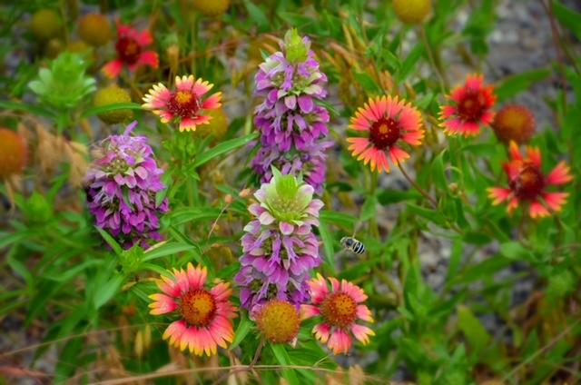

**Linden Wildflower Trails**

**Art & Photography Show**

**April 25 & 26, 2025**

**Cass County Courthouse**

**Exhibit Hours: Friday April 25, 2025, 1 to 4**

**Saturday April 26, 2025, 9 to 4**

**Artist’s Reception and Awards**

**Saturday, April 26, 2025**

**4 P.M.**

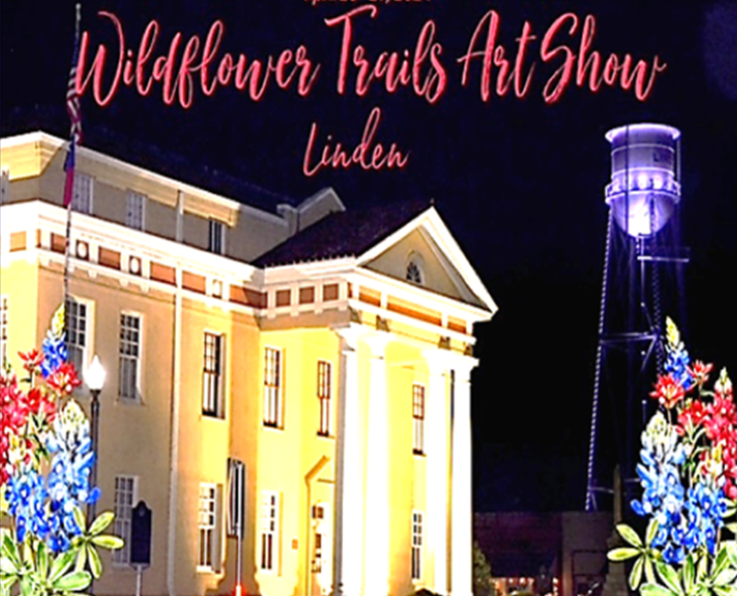

**Show Rules, Awards and Prizes , Show Entry Coupons**

**Linden Wildflower Trails Art Show Contacts:**

**Art Show Director: Gail Dorgan 903-826-0222**

**gaildorgan@gmail.com**

**WFT Event Coordinator: JoAnna Duncan 903-733-5915**

**olde1852marketco@gmail.com**